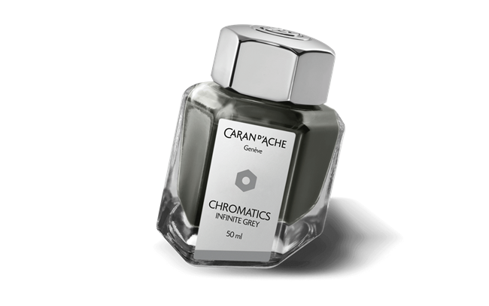

Infinite Grey CHROMATICS Ink Bottle 50 ml

Caran d’Ache uses its special savoir-faire to offer lovers of handwriting a collection of ink bottles with 12 colours inspired by the prism.  
From ultramarine blue to luxuriant green, from shimmering orange to passionate red, they give the words a soul and the text a uniquely vibrant style.  
Caran d’Ache inks show their pedigree in a box that is worthy of presenting their intense colours: the glass bottles adopt the shape of a prism, playing with the reflections of the light and enriching the colours they contain.